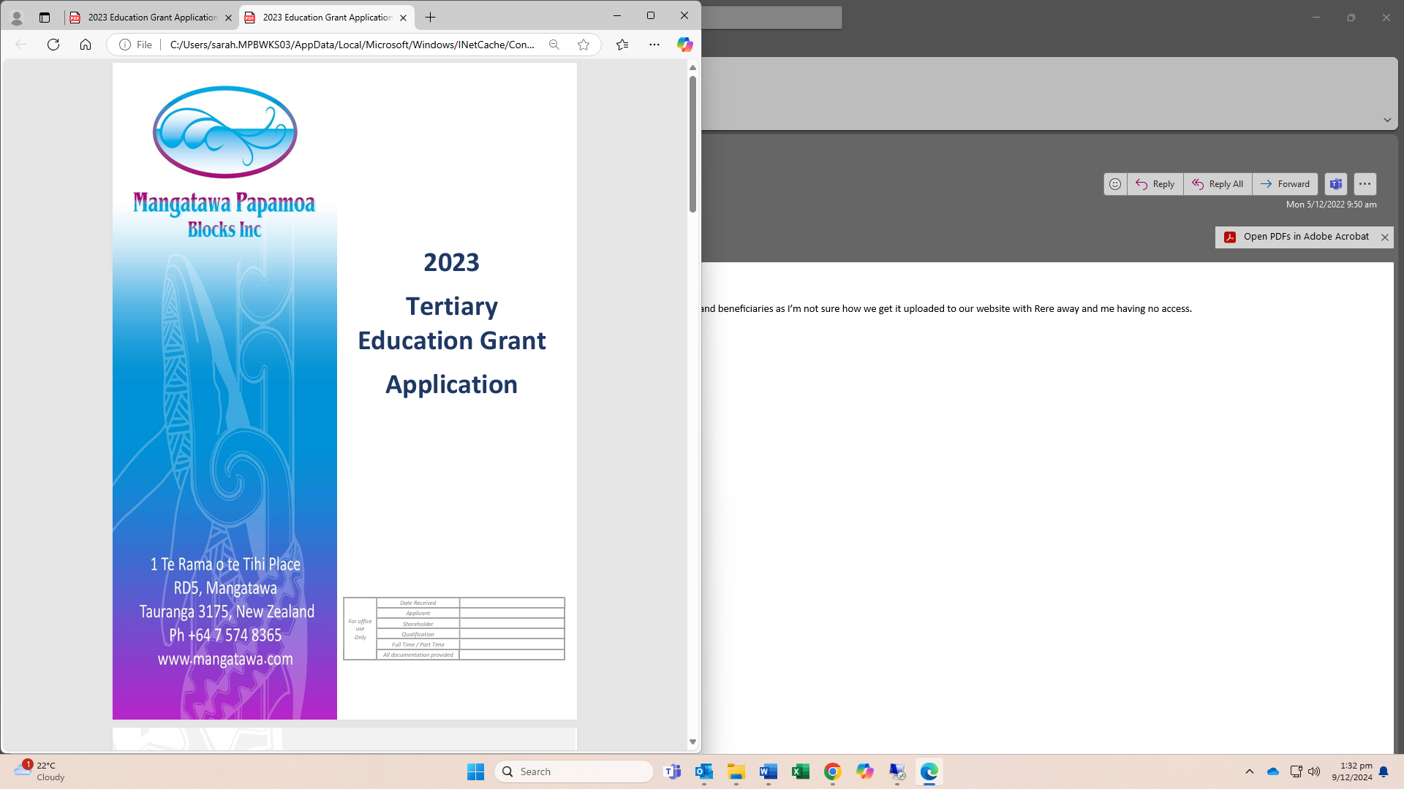
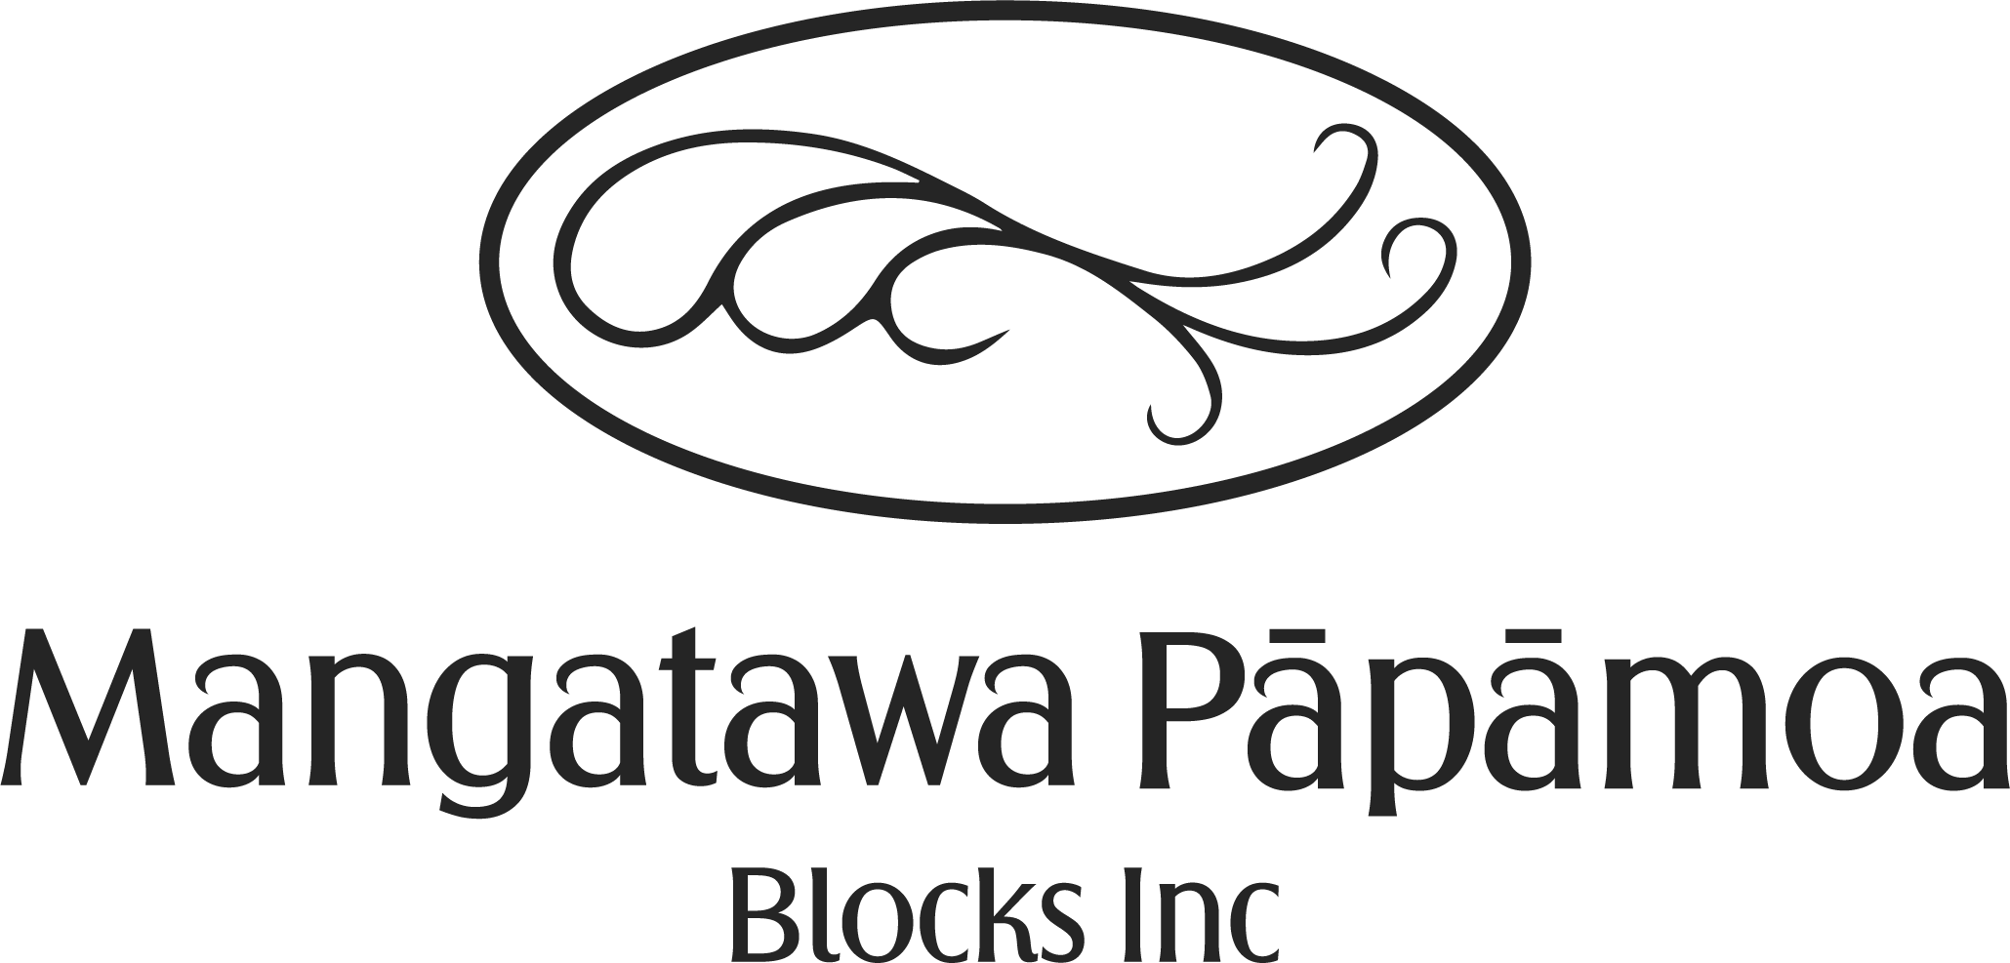
2025
Tertiary Education Grant
Application

The Committee of Management of the Mangatawa Pāpāmoa Blocks Incorporation is dedicated to the stewardship of significant assets on behalf of our shareholders. We are proud to invest in the future of our community by allocating a portion of our annual profits to support the educational aspirations of our shareholders and their descendants. Each year, we are delighted to provide financial assistance to help our students achieve their academic goals and reach their full potential.

Mangatawa Pāpāmoa Blocks Incorporation and the Māori Education Trust is proud to be part of a Tripartite Agreement that enhances our commitment to education. This agreement allows us to collaborate effectively with MET and other partners to provide even greater support to our shareholders and their descendants. Through this partnership, we are able to offer comprehensive financial assistance, ensuring that our students have the best possible opportunities to achieve their academic goals.

“Ko te manu e kai ana I te miro, nōna te ngahere, ko te manu kai ana i te matauranga, nōna te ao”

“The bird that consumes the miro berry owns the forest, the bird that consumes knowledge owns the world”

**Please read this form carefully, answer all questions and supply all information requested**

Checklist
All questions in the application have been answered
Copies of proof of enrolment are attached
Copies of previous year’s results are attached (if applicable)
Bank authorised bank account confirmation is attached
Applicant/Guardian has signed the form
Sponsoring Shareholder has signed the form

Under the terms of the Privacy Act 2020, the information supplied will be used only in connection with this application. Please forward your completed application to:

Mangatawa Pāpāmoa Blocks Incorporation
1 Te Rama o te Tihi Place
RD5 Mangatawa
Tauranga 3175
NEW ZEALAND

Or via email to
secretary@mangatawa.com

Closing Date: 07 March 2025
Late applications will not be accepted

SECTION A: PERSONAL DETAILS
Family Name(s): |  | First Name(s)
Gender: Male / Female | Age: |  | Date of Birth: / / /
Address: ……………………………………………………………  …………………………………………………………… |  |  | Home: ( )
 |  |  | Work: ( )
 |  |  | Mobile: ( )
Email:
Are you an owner in Mangatawa Pāpāmoa Blocks Incorporation Yes / No |  |  |  |  | What is the relationship to Owner?
SECTION B: WHAKAPAPA (Compulsory – you must complete this section)
Complete the whakapapa to show clearly that you are a direct descendant of a current **shareholder of Mangatawa Pāpāmoa Blocks Incorporation. The Committee of Management will verify the information supplied.
Note: (** If succession has not occurred this application will not be approved.)
WHAKAPAPA
………………………………………………………………  Great Grandparents |  |  |  | ………………………………………………………………  Great Grandparents
………………………………………………………………………  Grandparents |  |  |  | ……………………………………………………………..  Grandparents
………………………………………………………………………  Father |  |  |  | ………………………………………………………………  Mother
………………………………………………………………………
Applicant

SECTION C: EDUCATION DETAILS
Course Title (e.g. Bachelor of Education)
Name and City of Institute:
What level Qualification are you pursuing: |  |  | Duration of course/ years:
State the year of your study (e.g. 1st of 3 years): |  |  | Please circle: Full time / Part time
Please tick the box that applies
Polytechnic / Wānanga | Undergraduate |  |  |  | Postgraduate
Previous Study
Course Title:
Name of Institute:
Year(s) Attended: | Completed Yes / No
SECTION D: SCHOLARSHIPS
Other Scholarships available (Please indicate if you are applying for either of scholarships)
Victoria Taihonoa Partnerships:
The Victoria University Taihonoa Scholarship has offered a unique opportunity for Mangatawa Pāpāmoa Blocks Inc, to match, dollar-for-dollar, a contribution by Victoria University of Wellington for Scholarship/award to students attending Victoria. If you are attending Victoria University Wellington and would like to know more about the scholarship, please refer to our website or contact the office.
Ebba Te Tua Scholarship:
The Ebba Te Tua Scholarship aligns to the mutual goals of the MPBI and the Generus Living partnership – to recognise the importance of social matters and provide an opportunity to Mangatawa Shareholders. This Scholarship supports the teachers supply pressures in the areas of Te Reo Māori and Māori Medium. If you would like to know more or you are Interested in applying for this scholorship, please refer to our website or contact the office.

SECTION E: OTHER GRANTS
Have you applied for any other grants/scholarships | Yes / No
If yes, please state which and the amount: ……………………………………………………………………………………………………………………………………………
……………………………………………………………………………………………………………………………………………
………………………………………………………………………………………………………………………………………….
SECTION F: BANK ACCOUNT DETAILS
Bank: | Account Name:
Account Number:
IMPORTANT: You MUST attach a bank confirmation to verify the nominated bank account number.
SECTION G: DECLARATION
Applicant Declaration
Note: If the applicant is under 17 years old this section must be also signed by a parent/guardian
I certify to the best of my knowledge that the information in this application is true and correct.
Signature of Applicant:
Name of Guardian: | Parent/Guardian Signature
Shareholder Declaration
Signature of Shareholder:
Shareholder Name: |  | Date:

